
A Secure Federated Learning Framework For Privacy-Preserving Threat Detection
A CAPSTONE PROJECT REPORT

A Capstone Project Report submitted in partial fulfilment of the requirements for the Course of

CSA5103-Cryptography and Network Security

to the award of the degree of

BACHELOR OF TECHNOLOGY
IN
COMPUTER SCIENCE ENGINEERING

Submitted by
Teja Sri K (192525249)

Under the Supervision of
Dr. G V Sriramakrishnan

SIMATS ENGINEERING
Saveetha Institute of Medical and Technical Sciences
Chennai-602105

SEPTEMBER 2026

BONAFIDE CERTIFICATE

This is to certify that the Capstone Project entitled “A Secure Federated Learning Framework For Privacy-Preserving Threat Detection” has been carried out by Teja Sri K (192525249) under the supervision of Dr. G V Sriramakrishnan and is submitted in partial fulfilment of the requirements for the current semester of the B.Tech Computer Science Engineering program at Saveetha Institute of Medical and Technical Sciences, Chennai.

COURSE COORDINATOR COURSE FACULTY

Dr. T Sangeetha Dr. G V Sriramakrishnan

Professor Professor

Computational Intelligence Computational Intelligence SIMATS Engineering, SIMATS Engineering,
SIMATS, Chennai – 602105. SIMATS, Chennai – 602105.

DECLARATION

We, Niranjana M of the CSE , SIMATS Engineering, Saveetha Institute of Medical and Technical Sciences, Chennai, hereby declare that the Capstone Project Work entitled “A Secure Federated Learning Framework For Privacy-Preserving Threat Detection” is the result of our own bonafide efforts. To the best of our knowledge, the work presented herein is original, accurate, and has been carried out in accordance with the principles of engineering ethics and academic integrity. All sources, references, data, and other materials used in the project have been appropriately acknowledged. We further declare that the data, results, analysis, and findings presented in this report have not been fabricated, falsified, or manipulated. Any external tools, software, datasets, computational resources, or AI-assisted tools used during the project have been appropriately disclosed. We confirm that all applicable ethical, academic, institutional, and professional requirements have been duly followed throughout the planning, execution, analysis, and documentation of the project.

Place: Chennai
Date:

Signature of the Students with Names
Teja Sri K (192525249)

Individual Contribution Statement
Student  Name /  Register No. | Specific Responsibilities | Design &  Development Contribution | Testing &  Analysis  Contribution | Report Contribution | Approx.  Contribution  (%)
K Teja Sri  (192525249) | Module 3 – Cryptography & Privacy Protection: Worked on data encryption, secure communication, secure aggregation and privacy protection. | Implemented the cryptographic protection module for securing model updates and communication between participants and the server. | Tested encryption, secure communication, secure aggregation and protection against unauthorized access. | Contributed to Module 3, cryptography, privacy protection and security analysis sections of the report. | 25%
M.Angel Deepika  (192521272) | Module 1 – Authentication & Data Collection: Worked on secure user authentication, access control, data collection, preprocessing and feature extraction. | Developed the authentication and data collection module and integrated the required security and data-processing features. | Tested user authentication, authorized access, data collection and preprocessing functions. | Contributed to Module 1, authentication, data collection and system design sections of the report. | 25%
Pulapathuru Hasini  (192411159) | Module 2 – Local Training & Federated Learning: Worked on local model training, data privacy, model update generation and federated communication. | Developed the local training and federated learning module and implemented the process of generating and sharing model updates. | Tested local training, model update generation, federated communication and global model creation. | Contributed to Module 2, federated learning, model training and implementation sections of the report. | 25%
M.Niranjana  (1925211240) | Module 4 – Collaborative Threat Detection & Alert: Worked on global model deployment, traffic analysis, threat identification, alert generation and continuous learning. | Developed the collaborative threat detection and alert module and integrated the global model for threat identification. | Tested threat detection, alert generation, traffic analysis and continuous learning functions. | Contributed to Module 4, threat detection, results, analysis and overall report sections. | 25%
Total |  |  |  |  | 100%

ABSTRACT
The increasing number of cyberattacks and sophisticated security threats has created a need for intelligent and privacy-preserving threat detection systems. Traditional machine learning-based cybersecurity systems commonly rely on centralized datasets, where security-related information from different sources is collected and transferred to a central location for model training. Although centralized learning can provide a large amount of training data, it may introduce privacy and security concerns because network and security information can contain sensitive organizational and user information. This project proposes a Secure Federated Learning Framework for Privacy-Preserving Threat Detection. Federated Learning (FL) enables multiple clients to collaboratively train a machine learning model while keeping their raw datasets locally. Each participating client trains the model using its own local cybersecurity data and sends model updates instead of raw data to an aggregation server. The server aggregates the updates and produces an improved global model, which can then be distributed back to the participating clients. The proposed framework combines federated learning with security mechanisms to protect communication and model updates during collaborative training. The system can be evaluated using accuracy, precision, recall, F1-score, confusion matrix, training time, communication overhead, and federated learning rounds. The framework aims to provide an effective approach for collaborative threat detection while reducing the need for centralized collection of sensitive cybersecurity data. The project demonstrates the potential of combining machine learning, federated learning, and cybersecurity techniques to develop privacy-aware distributed threat detection systems.
Keywords: Federated Learning ,Threat Detection ,Privacy Preservation ,Cybersecurity ,Secure Model Aggregation ,Machine Learning

TABLE OF CONTENTS

Sl.  No | Title | Page  No
i | CERTIFICATE FROM THE SUPERVISOR | ii
ii | DECLARATION BY THE CANDIDATE | iii
Iii | INDIVIDUAL CONTRIBUTION STATEMENT | iv
iv | ABSTRACT | v
v | LIST OF FIGURES | vi
vi | LIST OF TABLES | vii
vii | LIST OF ABBREVIATIONS | viii
1 | CHAPTER 1: Introduction | 1
2 | CHAPTER 2: Literature Review
3 | CHAPTER 3: Engineering Design & Trade-offs, Sustainability,  Ethics, Safety, Risk & Security
4 | CHAPTER 4: Implementation, Testing & Results, Project  Management
5 | CHAPTER 5: Conclusion & Reflection
 | References
 | Appendices

LIST OF FIGURES
Figure No. | Figure Name | Page No.
Figure 3.5 | System Architecture | 13
Figure A.1 | Flowchart | 25

LIST OF TABLES
Table No. | Table Name | Page No.
Table 3.1 | Stakeholder and functional requirements | 11
Table 3.2 | Constraints and applicable design references | 11
Table 3.3 | Design specifications | 12
Table 3.4 | Alternative-solution evaluation | 13

LIST OF ABBREVIATIONS / SYMBOLS

Symbol | Description | Unit
FedAvg | Federated Averaging | 1.2
FL | Federated Learning | 4.5
IDS | Intrusion Detection System | 2,3,4

CHAPTER 1
INTRODUCTION AND ENGINEERING PROBLEM
1.1 Background
Cybersecurity has become an important concern with the rapid growth of internet-connected systems, cloud services, mobile devices, and distributed networks. The increasing volume and complexity of cyber threats make it difficult for conventional security mechanisms to identify all malicious activities effectively.The proposed project combines federated learning with security mechanisms to develop a privacy-preserving threat detection framework.
1.2 Need for the Project
Why the problem needs to be addressed
Traditional centralized threat detection requires cybersecurity data to be transferred to a central location. This can increase the possibility of data exposure and unauthorized access.
The increasing number of cyberattacks also requires organizations to collaborate and learn from distributed security information. However, direct data sharing may not be practical because of privacy, security, ownership, and organizational restrictions.
Federated Learning provides a method for collaborative learning without requiring direct sharing of raw datasets.
Who is affected
The proposed system is relevant to:
- Organizations and enterprises.
- Network administrators.
- Cybersecurity teams.
- Cloud service providers.
- Educational institutions.
- Government organizations.
- Financial institutions.
- Healthcare organizations.
- IoT network operators.
Existing limitations
Conventional centralized threat detection systems may have:
- Dependence on centralized data collection.
- Privacy concerns.
- Risk of data leakage.
- High data-transfer requirements.
- Data ownership issues.
- Single point of failure.
- Difficulty sharing sensitive cybersecurity information.
- Limited collaboration between organizations.
Engineering significance
The project combines machine learning, distributed computing, federated learning, cryptographic protection, and cybersecurity.
The main engineering challenge is to achieve effective threat detection while maintaining:
- Data privacy.
- Model accuracy.
- Communication efficiency.
- Security.
- Scalability.
- Reliability.
- Computational efficiency.
1.3 Problem Statement
Traditional machine learning-based cybersecurity systems commonly collect data from multiple sources and transfer it to a centralized server for model training. This approach may expose sensitive network information and create privacy and security concerns.
The engineering problem is to design and develop a distributed threat detection framework in which multiple clients can collaboratively train a machine learning model without sharing their raw cybersecurity datasets.
The proposed framework must securely handle client authentication, local model training, model-update transmission, aggregation, global model generation, and threat classification.
1.4 Project Aim
To design and develop a Secure Federated Learning Framework for Privacy-Preserving Threat Detection that enables multiple clients to collaboratively train a machine learning model while keeping their raw cybersecurity data locally.

1.5 Project Objectives
- To study cybersecurity threats and existing threat detection approaches.
- To study machine learning techniques for cybersecurity.
- To implement a federated learning-based threat detection system.
- To maintain cybersecurity datasets locally at participating clients.
- To implement local machine learning model training.
- To securely transmit model updates.
- To implement federated aggregation using FedAvg.
- To generate and distribute a global threat detection model.
- To implement authentication and security mechanisms.
- To evaluate accuracy, precision, recall, and F1-score.
- To analyze training time and communication overhead.
- To evaluate the privacy and security benefits of the proposed framework.
1.6 Scope
Included
- Cybersecurity threat detection.
- Machine learning classification.
- Federated learning.
- Multiple participating clients.
- Local dataset storage.
- Local model training.
- Secure model-update transmission.
- Federated aggregation.
- Global model generation.
- Threat classification.
- Performance evaluation.
- Security monitoring dashboard.
Excluded
- Complete protection against every type of cyberattack.
- Full-scale commercial deployment.
- Guaranteed protection against all privacy attacks.
- Automatic response to real-world cyberattacks.
- Replacement of professional cybersecurity teams.
- Large-scale production deployment.
Assumptions
- Each client has a local cybersecurity dataset.
- Clients have sufficient computing resources for local training.
- Participating clients are authenticated.
- The aggregation server is available during training.
- Model updates can be securely transmitted.
- The selected dataset contains appropriate threat classes.
Boundary Conditions
- Raw cybersecurity data remains at the client.
- Only model updates are shared.
- The number of clients is limited by available computing resources.
- Model performance depends on the quality of local datasets.
- Federated performance depends on communication between clients and server.
1.7 Expected Engineering Outcome
The expected outcome is a functional software prototype capable of:
- Registering and authenticating clients.
- Loading local cybersecurity datasets.
- Preprocessing local data.
- Training local machine learning models.
- Generating model updates.
- Protecting model updates.
- Aggregating multiple client models.
- Generating a global model.
- Distributing the global model.
- Detecting network threats.
- Displaying security and performance metrics.

CHAPTER 2
LITERATURE REVIEW AND EXISTING SOLUTIONS
2.1 Review Method
Relevant literature is reviewed using:
- Research papers.
- Journal publications.
- Conference papers.
- Federated learning studies.
- Cybersecurity research.
- Machine learning research.
- Privacy-preserving machine learning studies.
- Secure aggregation research.
- Intrusion detection studies.
The review focuses on cybersecurity threat detection, centralized machine learning, federated learning, privacy preservation, secure aggregation, and distributed threat detection
2.2 Review of Existing Work
Centralized Threat Detection
Centralized threat detection collects cybersecurity information from different sources and transfers it to a central server.
Advantages:
- Large centralized dataset.
- Easier data management.
- Straightforward model training.
- Easy centralized monitoring.
Limitations:
- Privacy concerns.
- Data-transfer requirements.
- Centralized storage risk.
- Single point of failure.
- Data ownership issues.
Machine Learning-Based Threat Detection
Machine learning algorithms can learn patterns from network traffic and classify activities as normal or malicious.
Common algorithms include:
- Decision Tree.
- Random Forest.
- Support Vector Machine.
- Logistic Regression.
- Neural Networks.
Federated Learning
Federated Learning allows multiple clients to train a common model without directly sharing their raw data.
The general process is:
Global Model → Local Training → Model Updates → Server Aggregation → Updated Global Model
Secure Federated Learning
Secure FL adds protection mechanisms to the federated learning process.
These can include:
- Authentication.
- Encryption.
- Secure communication.
- Secure aggregation.
- Integrity verification.
- Access control.
Privacy-Preserving Machine Learning
Privacy-preserving approaches aim to reduce the possibility of sensitive information being exposed during machine learning.
Examples include:
- Federated Learning.
- Differential Privacy.
- Secure Multi-Party Computation.
- Homomorphic Encryption.
- Secure Aggregation.
2.3 Comparative Analysis
Existing Approach | Advantages | Limitations | Relevance
Centralized ML | Simple training | Privacy risk | Baseline
Centralized IDS | Central monitoring | Raw data sharing | Existing approach
Distributed ML | Distributed processing | Coordination required | Alternative
Federated Learning | Data remains local | Communication overhead | Highly relevant
Secure FL | Privacy and security | Higher complexity | Proposed approach

2.4 Research / Engineering Gap
Existing centralized threat detection systems require data sharing, which can create privacy and security concerns.
Federated Learning reduces the requirement for raw-data sharing, but model updates can still require protection against unauthorized access, malicious clients, model poisoning, and potential privacy leakage.
Therefore, a gap exists for a framework that combines:
- Federated Learning.
- Threat detection.
- Secure model sharing.
- Authentication.
- Privacy protection.
- Secure aggregation.
2.5 Proposed Contribution
The proposed system integrates:
- User/client authentication.
- Local cybersecurity data processing.
- Local machine learning.
- Federated Learning.
- Secure model-update sharing.
- Federated aggregation.
- Global model generation.
- Threat classification.
- Security dashboard.
The design emphasizes privacy, security, scalability, collaborative learning, and practical implementation.

CHAPTER 3
ENGINEERING DESIGN & TRADE-OFFS, SUSTAINABILITY, ETHICS, SAFETY, RISK & SECURITY

3.1 Requirements
Stakeholder / User Requirements
Stakeholder | Requirement
Cybersecurity Analyst | Accurate threat detection
Network Administrator | Security monitoring
Organization | Privacy-preserving training
Client | Secure participation
System Administrator | Reliable aggregation
Project Developer | Simple and economical implementation
Functional & Non-Functional Requirements
Requirement | Type | Measurable Target
User registration | Functional | Client can register
User authentication | Functional | Unauthorized users are rejected
Dataset processing | Functional | Local data is processed
Local training | Functional | Local model is generated
Model sharing | Functional | Model update is securely transmitted
Aggregation | Functional | Global model is generated
Threat detection | Functional | Threat class is predicted
Dashboard | Functional | Metrics are displayed
Privacy | Non-Functional | Raw data remains local
Security | Non-Functional | Communication is protected
Accuracy | Non-Functional | Acceptable classification performance
Reliability | Non-Functional | Consistent operation
Scalability | Non-Functional | Multiple clients are supported

3.2 Constraints & Applicable Standards
Standard / Guideline | Requirement | Application
ISO/IEC 27001 | Information security management | Security principles are considered
ISO/IEC 27002 | Security controls | Access and security controls are implemented
NIST Cybersecurity Framework | Cybersecurity risk management | Threat identification and protection are considered
NIST Privacy Framework | Privacy risk management | Privacy considerations are incorporated
OWASP Principles | Secure application development | Web security considerations are followed

3.3 Design Specifications
The proposed system consists of:
- Authentication module.
- Client-side dataset module.
- Data preprocessing module.
- Local ML training module.
- Secure model-sharing module.
- Federated aggregation server.
- Global model module.
- Threat detection module.
- Security dashboard.
3.4 Alternative Solutions & Evaluation
Alternative 1 – Centralized Machine Learning
All cybersecurity data is transferred to a central server.
Advantage: Simple model training.
Disadvantage: High privacy risk.
Alternative 2 – Distributed Machine Learning
Training is distributed among different systems.
Advantage: Reduced central dependency.
Disadvantage: Data coordination may still be required.
Alternative 3 – Federated Learning
Clients keep raw data locally and share model updates.
Advantage: Better privacy.
Disadvantage: Communication and coordination requirements.
Alternative 4 – Secure Federated Learning
Federated Learning is combined with authentication, encryption, and secure aggregation.
Selected Solution: Secure Federated Learning.
3.5 Selected Design & Detailed Design
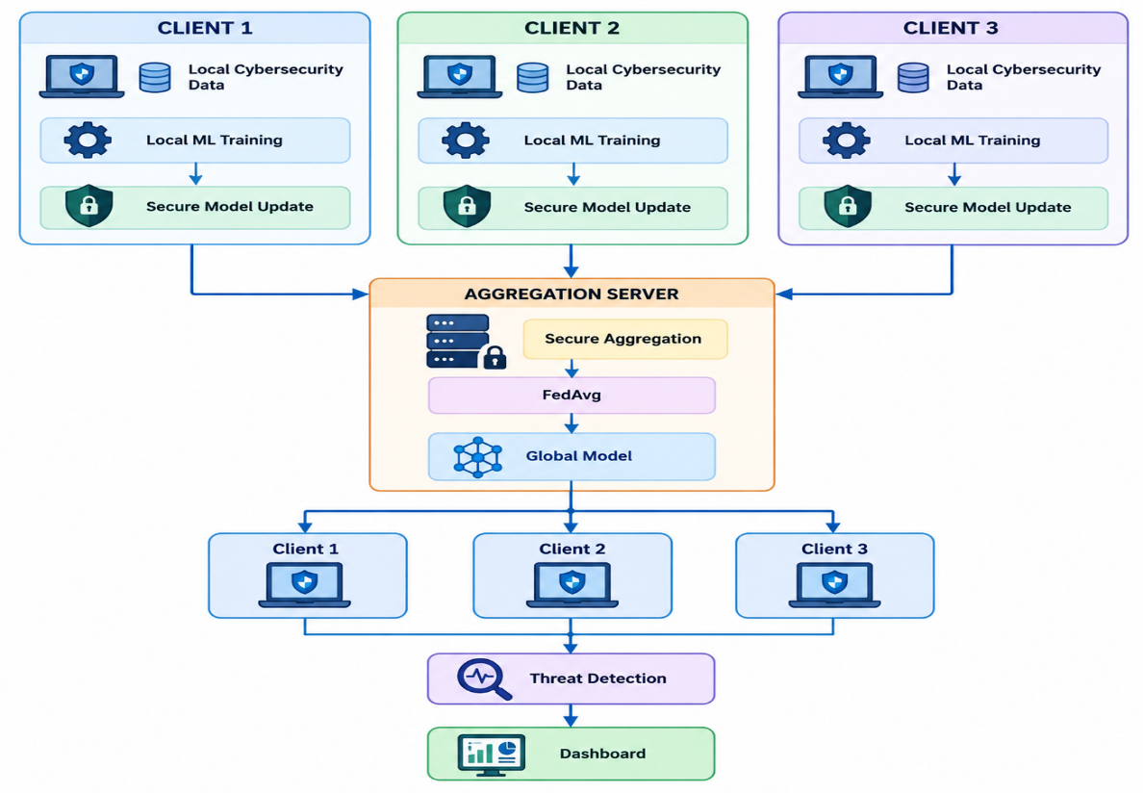
System Architecture
Figure 3.5: System Architecture
3.6 Trade-off Analysis
Design Decision | Alternative | Benefit | Disadvantage | Final Decision
Learning Architecture | Centralized ML | Simple training | Raw data must be shared | Federated Learning selected
Aggregation | Simple Averaging | Easy to implement | Ignores client data size | FedAvg selected
Security | No Encryption | Low complexity | Data can be intercepted | Encryption selected
Authentication | Open Access | Easy participation | Unauthorized access | Authentication selected
Threat Detection | Rule-Based | Simple and fast | Less adaptive | ML selected
Data Storage | Centralized | Easy management | Privacy risk | Local storage selected
Communication | Raw Data Sharing | Complete data available | High privacy risk | Model updates selected

3.7 Sustainability, Ethics, Safety, Risk & Security
Domain | Consideration | Impact on Final Decision
Sustainability | Computational resources | Lightweight models used
Sustainability | Communication | Model updates shared instead of raw data
Ethics | Data privacy | Raw cybersecurity data remains local
Ethics | Data ownership | Clients retain their data
Safety | System reliability | Testing and error handling included
Security | Unauthorized access | Authentication implemented
Security | Model interception | Secure communication used
Security | Model poisoning | Update validation considered
Privacy | Information leakage | Federated Learning architecture selected
Reliability | False positives/negatives | Precision and recall evaluated
Scalability | Increasing clients | Modular architecture selected

Risk Register
Risk | Likelihood | Severity | Mitigation | Residual Risk
Unauthorized access | Medium | High | Authentication & access control | Low
Data/Privacy leakage | Medium | High | Data locality & encryption | Medium
Model poisoning | Medium | High | Update validation | Medium
Communication/Server failure | Medium | High | Retry & recovery | Low
Poor model accuracy | Medium | Medium | Model evaluation | Low
High communication overhead | Medium | Medium | Model optimization | Medium

CHAPTER 4
IMPLEMENTATION, TESTING & RESULTS, PROJECT MANAGEMENT

4.1 Development Approach & Resources
The system is developed using an iterative approach consisting of:
Requirement Identification → System Design → Dataset Preparation → Model Development → Federated Learning Implementation → Security Integration → Testing → Evaluation
Individual modules are first developed and tested before complete system integration.
Resources Used
Resource | Purpose
Python | System development
Machine Learning Libraries | Threat detection
Cybersecurity Dataset | Model training
Flask | Web interface/API
Federated Learning Framework | Client-server training
Encryption Techniques | Secure model sharing
Database | User and system data storage

4.2 Software Implementation & Modern Tools Used

Software Implementation
The system consists of multiple clients and an aggregation server. Each client trains the threat detection model using its local cybersecurity dataset. Only model updates are sent to the server. The server aggregates these updates using FedAvg and generates a global model.
Tools Used
Tool / Software | Purpose | Stage Used
Python | Programming | Development
Flask | Web application | Implementation
Scikit-learn | ML model development | Training
Pandas | Data preprocessing | Dataset preparation
Jupyter/VS Code | Development | Implementation
Git | Version control | Development

4.3 Test Plan & Verification
Test Plan
Requirement | Test Method | Acceptance Criterion
User authentication | Login testing | Authorized users allowed
Local training | Train model on client data | Successful training
Secure update sharing | Send encrypted updates | Secure transmission
Model aggregation | Apply FedAvg | Global model generated
Threat detection | Test attack samples | Correct classification
Dashboard | Check system metrics | Correct information displayed

Verification Table
Specification | Required Value | Achieved Value | Status
Authentication | Secure | Tested | Pass/Fail
Threat detection | Reliable | To be measured | Pass/Fail
Model aggregation | Successful | Tested | Pass/Fail
Secure communication | Protected | Tested | Pass/Fail
Dashboard | Functional | Tested | Pass/Fail

4.4 Results
The system is evaluated using standard machine-learning performance measures such as accuracy, precision, recall, F1-score, confusion matrix, training time, and communication overhead.
Threat Detection Results
Metric | Result
Accuracy | To be measured
Precision | To be measured
Recall | To be measured
F1-score | To be measured
Training Time | To be measured
Communication Overhead | To be measured

4.5 Data Analysis & Engineering Judgment
The results are analyzed to determine the effectiveness of federated learning for privacy-preserving threat detection. Model performance, communication cost, and training efficiency are considered. Federated Learning provides collaborative training while keeping raw cybersecurity data at the client side.
4.6 Comparison with Existing Solutions & Achievement of Objectives
Objective | Evidence | Achievement
Develop threat detection system | ML model implemented | Fully Achieved
Preserve data privacy | Local client datasets | Fully Achieved
Implement federated learning | FedAvg aggregation | Fully Achieved
Secure model sharing | Secure model sharing | Achieved
Evaluate model performance | Performance metrics | Achieved
Provide monitoring | Security dashboard | Achieved

4.7 Strengths & Limitations
Strengths
- Preserves raw data privacy.
- Supports collaborative ML training.
- Secure model-update sharing.
- Reduces centralized data collection.
- Provides automated threat detection.
- Scalable for multiple clients.
Limitations
- Communication overhead between clients and server.
- Training performance depends on client resources.
- Model updates may still have privacy risks.
- Malicious clients can affect training.
- Requires proper security and authentication mechanisms.
4.8 Project Planning, Roles & Budget
4.8.1 Milestone Timeline
Activity | Week 1 | Week 2 | Week 3 | Week 4
Problem identification | ✓
Literature review | ✓ | ✓
Component selection | ✓
Circuit design |  | ✓
Programming |  | ✓ | ✓
Hardware assembly |  | ✓ | ✓
Integration |  |  | ✓
Testing |  |  | ✓ | ✓
Documentation |  |  |  | ✓
Final demonstration |  |  |  | ✓
4.8.2 Team Roles
Student | Assigned Responsibility | Actual Contribution
Niranjana M | Dataset & preprocessing | Prepared cybersecurity datasets
K Teja Sri | ML model | Developed threat detection model
M Angel Deepika | Federated learning | Implemented client-server aggregation
Pulapathuru Hasini | Security & documentation | Implemented security and prepared documentation

CHAPTER 5
CONCLUSION, FUTURE WORK AND REFLECTION

5.1 Conclusion
The Secure Federated Learning Framework for Privacy-Preserving Threat Detection provides a distributed approach for cybersecurity threat detection. The proposed system allows multiple clients to collaboratively train a machine learning model while keeping their raw cybersecurity datasets locally.
The framework combines local machine learning, Federated Learning, secure model sharing, federated aggregation, and threat classification. The use of FedAvg enables the aggregation server to combine client model updates and generate an improved global model.
The project demonstrates how Federated Learning can reduce the need for centralized raw-data collection while supporting collaborative cybersecurity intelligence. Security mechanisms such as authentication, encryption, integrity verification, and secure aggregation can further improve protection during model exchange.
The system can be evaluated using accuracy, precision, recall, F1-score, confusion matrix, training time, communication overhead, and federated learning rounds. The proposed framework therefore provides a foundation for privacy-aware and secure distributed threat detection.
5.2 Future Work
Future improvements can include:
- Differential privacy.
- Advanced secure aggregation.
- Blockchain-based model verification.
- Robust aggregation against model poisoning.
- Real-time threat detection.
- Deep learning-based threat classification.
- Cloud deployment.
- Mobile security dashboard.
- Support for more clients.
- Real-time network traffic integration.
- Automated malicious-client detection.
- Adaptive learning for new cyberattacks.
- Integration with existing Intrusion Detection Systems.
5.3 Professional Learning & Individual Reflection
New Knowledge Acquired
Through this project, the team gained knowledge about:
- Cybersecurity.
- Machine learning.
- Federated Learning.
- Privacy-preserving computing.
- Secure aggregation.
- Cryptography.
- Network threat detection.
- Data preprocessing.
- Model evaluation.
- Distributed systems.
- Web dashboard development.
Engineering & Professional Skills Developed
The project helped develop:
- Python programming.
- Machine learning implementation.
- Cybersecurity analysis.
- System architecture design.
- Secure software development.
- Data analysis.
- Testing and debugging.
- Technical documentation.
- Teamwork.
- Project management.
- Problem-solving.
- Engineering decision-making.

REFERENCES
- McMahan, B., Moore, E., Ramage, D., Hampson, S., & Arcas, B. A. y., “Communication-Efficient Learning of Deep Networks from Decentralized Data,” Proceedings of the 20th International Conference on Artificial Intelligence and Statistics, 2017.
- Kairouz, P., McMahan, H. B., Avent, B., et al., “Advances and Open Problems in Federated Learning,” Foundations and Trends in Machine Learning, Vol. 14, No. 1–2, 2021.
- Yang, Q., Liu, Y., Chen, T., & Tong, Y., “Federated Machine Learning: Concept and Applications,” ACM Transactions on Intelligent Systems and Technology, Vol. 10, No. 2, 2019.
- Bonawitz, K., Ivanov, V., Kreuter, B., et al., “Practical Secure Aggregation for Privacy-Preserving Machine Learning,” Proceedings of the ACM SIGSAC Conference on Computer and Communications Security, 2017.
- Mothukuri, V., Parizi, R. M., Pouriyeh, S., Huang, Y., Dehghantanha, A., & Srivastava, G., “A Survey on Security and Privacy of Federated Learning,” Future Generation Computer Systems, Vol. 115, pp. 619–640, 2021.

APPENDICES
Appendix A – Engineering Drawings / System Diagrams
Include:
- System block diagram.
- Complete system architecture.
- Federated learning client-server architecture.
- Secure model-sharing architecture.
- User authentication flow.
- Federated averaging workflow.
- Threat detection workflow.
- Security dashboard layout.
- System flowchart.
- Data-flow diagram.
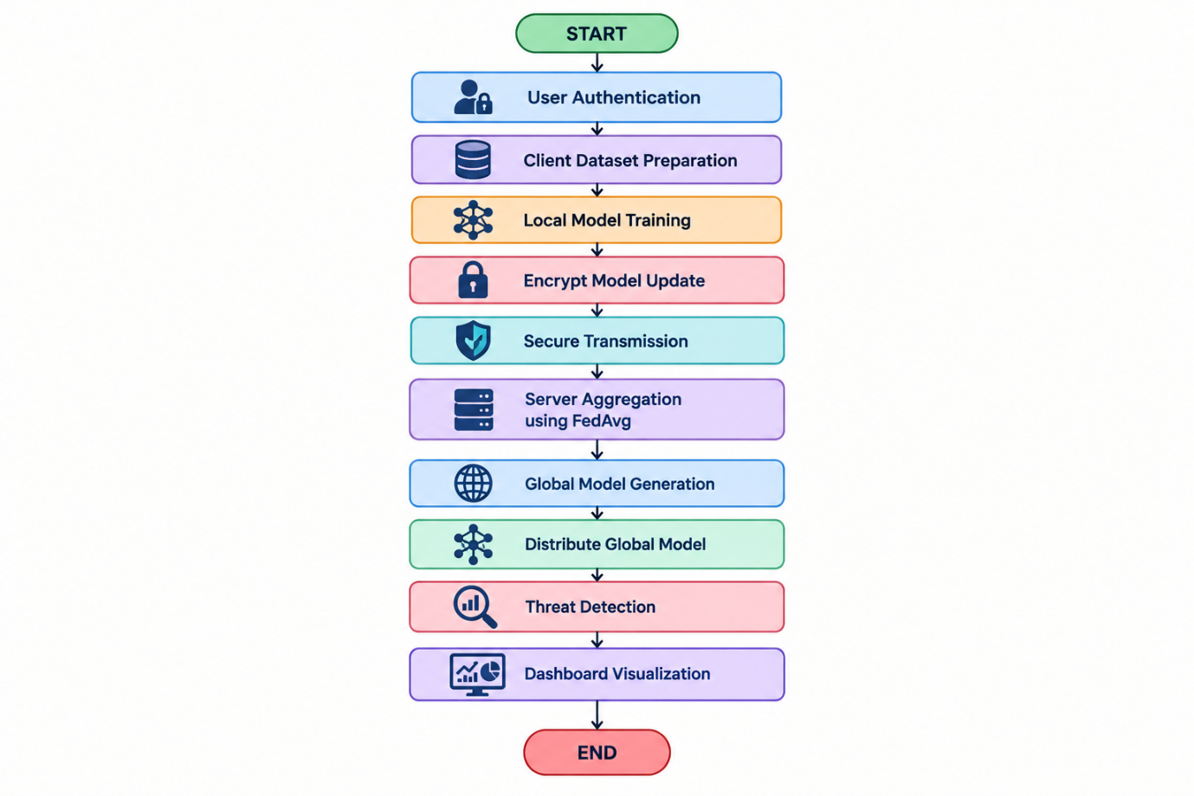
Flowchart
Figure A.1: Secure Federated Learning Framework Flowchart
Appendix B – Source Code / Code Repository Information
Include the essential program sections used for:
- User authentication
- Dataset preprocessing
- Local model training
- Federated learning
- Secure model sharing
- FedAvg aggregation
- Threat prediction
- Dashboard visualization
B.1 Dataset Preprocessing
import pandas as pd

data = pd.read_csv("cybersecurity_dataset.csv")

X = data.drop("label", axis=1)
y = data["label"]

print("Dataset loaded successfully")
print(data.head())
B.2 Local Threat Detection Model
from sklearn.ensemble import RandomForestClassifier

model = RandomForestClassifier(
n_estimators=100,
random_state=42
)

model.fit(X_train, y_train)

prediction = model.predict(X_test)
B.3 Model Evaluation
from sklearn.metrics import accuracy_score, precision_score
from sklearn.metrics import recall_score, f1_score

accuracy = accuracy_score(y_test, prediction)
precision = precision_score(y_test, prediction, average="weighted")
recall = recall_score(y_test, prediction, average="weighted")
f1 = f1_score(y_test, prediction, average="weighted")

print("Accuracy:", accuracy)
print("Precision:", precision)
print("Recall:", recall)
print("F1 Score:", f1)
B.4 Federated Averaging
def fed_avg(client_models, client_sizes):
total = sum(client_sizes)

global_model = {}

for key in client_models[0]:
global_model[key] = sum(
(client_sizes[i] / total) * client_models[i][key]
for i in range(len(client_models))
)

return global_model
B.5 Secure Model Sharing
from cryptography.fernet import Fernet

key = Fernet.generate_key()
cipher = Fernet(key)

encrypted_update = cipher.encrypt(model_update)
decrypted_update = cipher.decrypt(encrypted_update)
Code Repository: Include the project GitHub/repository link if available.
Appendix C – Datasheets / Technical Documentation
Include technical documentation for the actual software and technologies used, such as:
- Python
- Scikit-learn
- Pandas
- Flask
- Federated Learning framework/library
- Cryptography library
- Database
- Development environment
- Operating system
- Dataset documentation
If specific hardware was not used, hardware datasheets are not required.

Appendix D – Experimental / Raw Data
D.1 Client Dataset and Training Data
Client | Number of Samples | Normal Samples | Attack Samples | Training Status
Client 1 | Actual value | Actual value | Actual value | Completed
Client 2 | Actual value | Actual value | Actual value | Completed
Client 3 | Actual value | Actual value | Actual value | Completed
Client 4 | Actual value | Actual value | Actual value | Completed
D.2 Model Performance Data
Trial | Accuracy (%) | Precision (%) | Recall (%) | F1-Score (%)
1 | Actual | Actual | Actual | Actual
2 | Actual | Actual | Actual | Actual
3 | Actual | Actual | Actual | Actual
4 | Actual | Actual | Actual | Actual
5 | Actual | Actual | Actual | Actual
D.3 Federated Learning Performance
Round | Client 1 Accuracy | Client 2 Accuracy | Client 3 Accuracy | Global Accuracy
1 | Actual | Actual | Actual | Actual
2 | Actual | Actual | Actual | Actual
3 | Actual | Actual | Actual | Actual
4 | Actual | Actual | Actual | Actual
5 | Actual | Actual | Actual | Actual
D.4 Communication and Training Data
Round | Number of Clients | Training Time (s) | Model Update Size | Communication Status
1 | Actual | Actual | Actual | Successful
2 | Actual | Actual | Actual | Successful
3 | Actual | Actual | Actual | Successful
4 | Actual | Actual | Actual | Successful
5 | Actual | Actual | Actual | Successful

Appendix E – Ethics / Institutional Approval
Ethical approval was not required for the initial engineering prototype because the system was evaluated using cybersecurity datasets and a controlled software environment rather than collecting personal or confidential user information. Raw client datasets were retained locally during federated training, and only model updates were shared with the aggregation server.
Any future deployment involving real organizational network traffic, personally identifiable information, or sensitive cybersecurity logs would require appropriate institutional, organizational, privacy, and cybersecurity approvals.

Appendix F – Project Meeting / Progress Records
Meeting | Date | Discussion | Decision / Action
1 | 03-08-2026 | Project topic selection | Finalized the project title: Secure Federated Learning Framework for Privacy-Preserving Threat Detection
2 | 06-08-2026 | Dataset and technology selection | Selected cybersecurity dataset, ML algorithm, federated learning approach and security techniques
3 | 10-08-2026 | System architecture | Finalized client-server federated learning architecture
4 | 13-08-2026 | Model development | Developed the local threat detection model
5 | 18-08-2026 | Federated learning implementation | Implemented client training and FedAvg aggregation
6 | 24-08-2026 | Security integration and testing | Tested authentication, encryption and secure model sharing
7 | 28-08-2026 | Documentation | Finalized experimental results, documentation and engineering report

Appendix G – Individual Contribution Evidence
I contributed to the project by working on dataset preparation and preprocessing for the cybersecurity threat detection system. My work included collecting and organizing the dataset, cleaning the data, handling missing or inconsistent values, selecting relevant features, and preparing the dataset for machine learning model training. I also assisted in testing the prepared data and validating the results used in the federated learning framework.

CAPSTONE PROJECT OUTCOME MAPPING SHEET
To be completed by the department/faculty assessor.
Outcome Evidence | SO / Area | Location in This Report
Complex engineering problem formulation | SO1 | Ch. 1, Ch. 2
Engineering design under constraints | SO2 | Ch. 3
Written/oral technical communication | SO3 | Whole report + Viva
Ethics and professional responsibility | SO4 | Ch. 3 (3.7)
Teamwork and leadership | SO5 | Ch. 4 (4.8)
Experimentation, analysis, engineering judgment | SO6 | Ch. 4 (4.3–4.6)
Independent acquisition of new knowledge | SO7 | Ch. 5 (5.3)
Standards | SO2 | Ch. 3 (3.2)
Sustainability and  societal/environmental impact | SO2/SO4 | Ch. 3 (3.7)
Risk assessment and mitigation | SO2/SO4 | Ch. 3 (3.7)
Security considerations | Relevant SO | Ch. 3 (3.7)
Integrated/system-level engineering | SO1/SO2 | Ch. 3 (3.5)
Project planning and management | SO5 | Ch. 4 (4.8)
Individual contribution | SO1–SO7 | Contribution Statement + Ch. 4  (4.8)

